**ANALYSIS OF YAHOO FINANCIAL STOCK DATA**

Throughout the analysis of the dataset, I have taken a question-answer based approach to understanding the data. Below are the insights I gained from the analysis:

* The dataset contains approximately **603 thousand stock** records from 491 different companies. NVR Inc and Booking Holdings Inc (BKNG) have the highest single daily stock record.

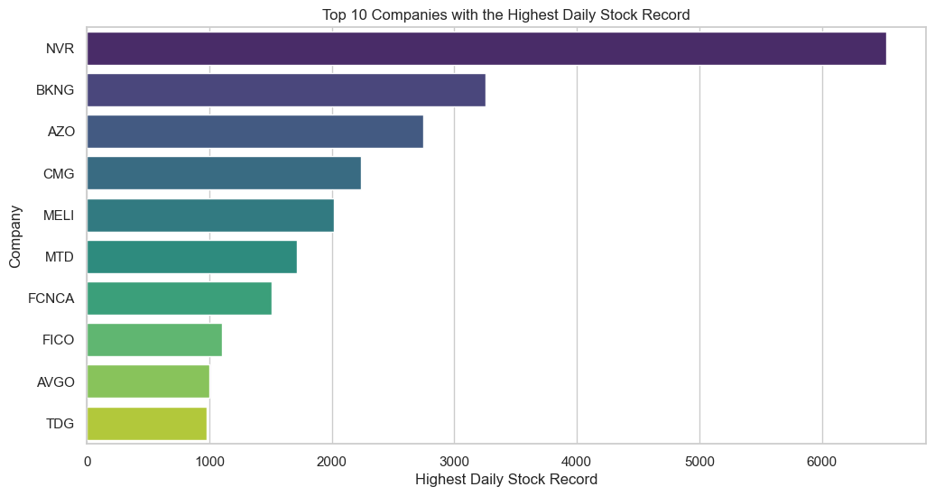

* **Tesla Inc and Apple Inc have the highest average trading volume.**

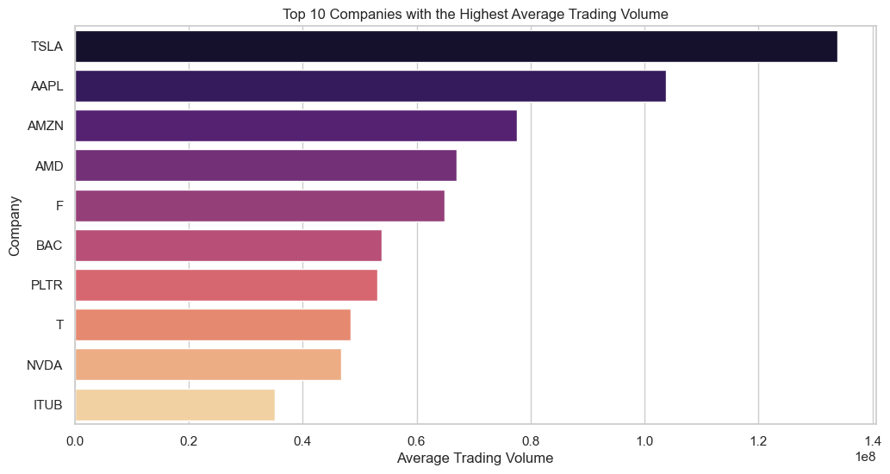

* A striking trend we can observe is that **from 2019 up to 2021, Meta stocks top the Price chart**. **However, there is a retrogradation from 2021 to 2023**. A tentative reason would be that this is due to the Pandemic.

Another striking observation is that Eli Lilly and Company (LLY) stock has been increasing steadily from 2019 and now tops the price chart. **Hence, a potential investment opportunity is to invest in LLY stocks.**

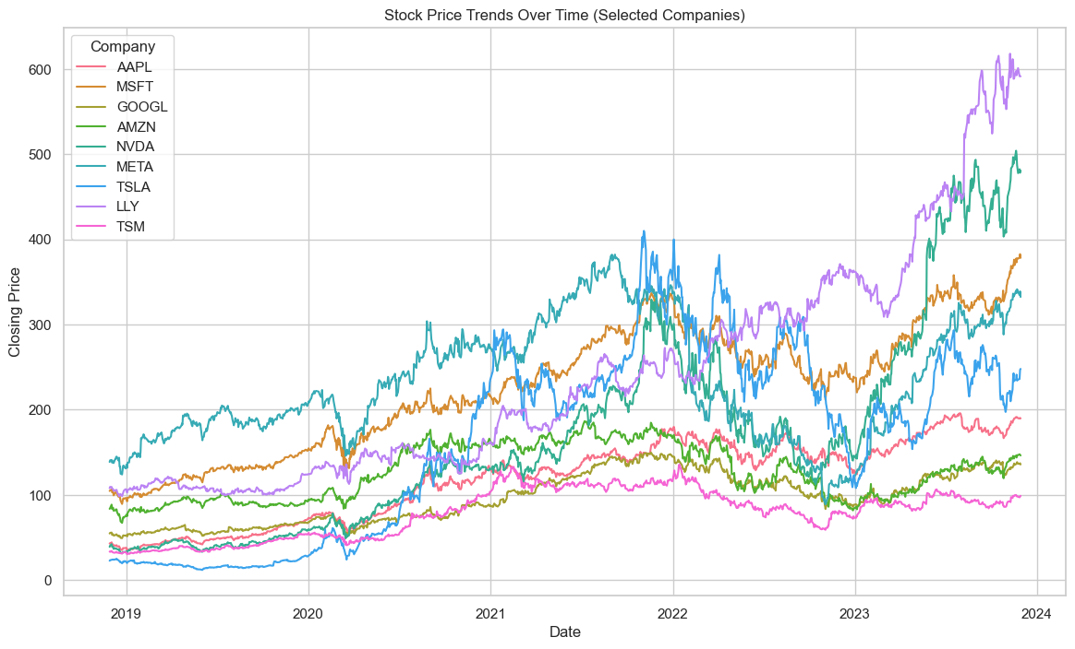

In order to visualize the trend more closely, a contrasting color plot has been provided below.

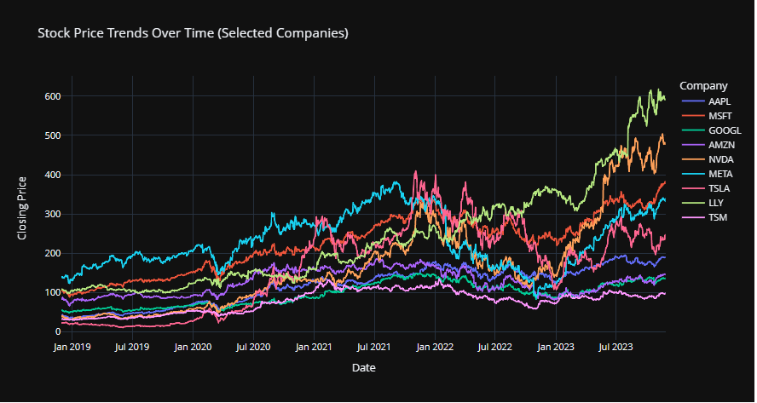

* June, July, August and September have a higher stock price.

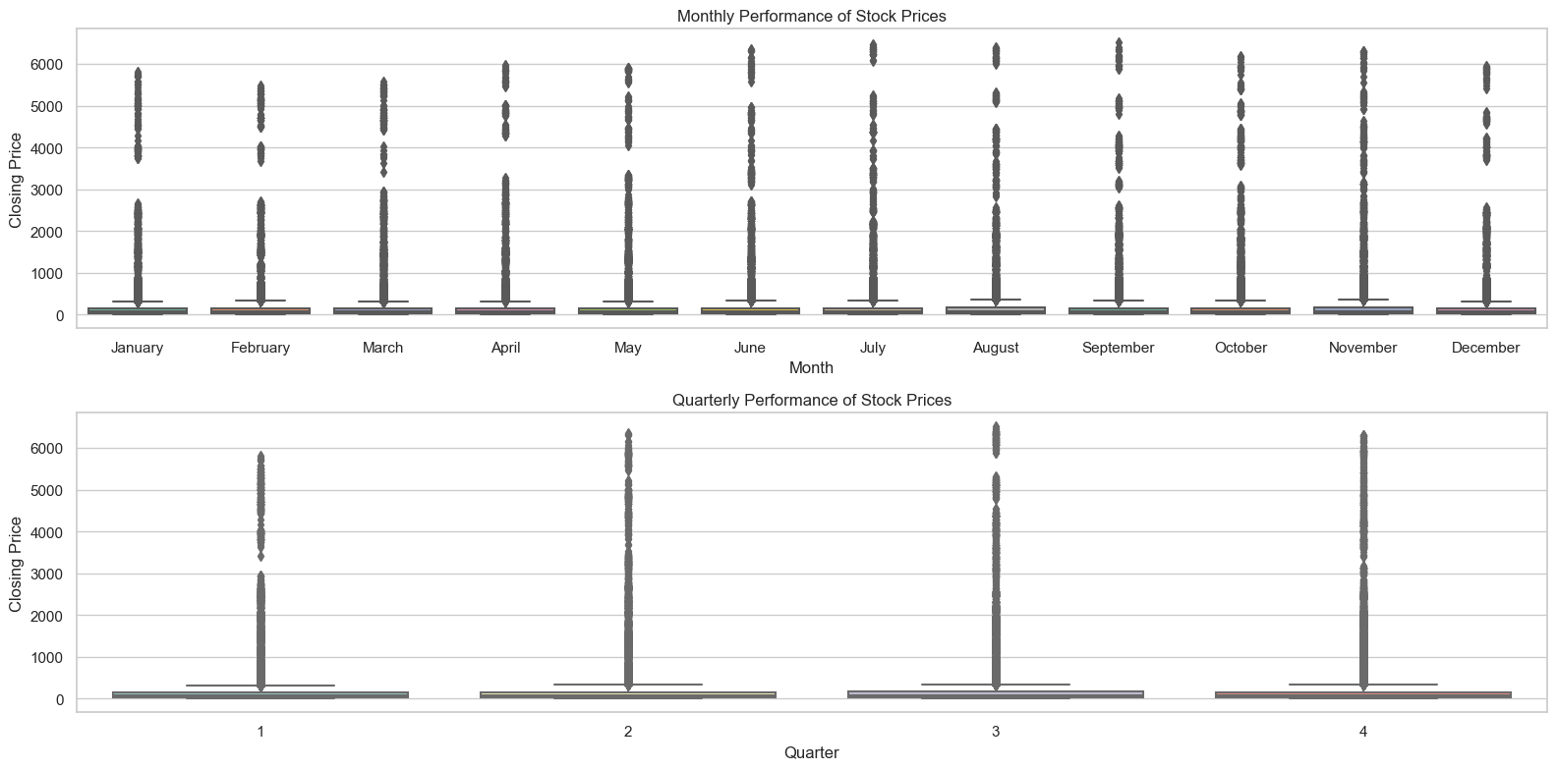

* It can be observed that for Tesla, as the trading volume increases, there is a decrease in closing price.

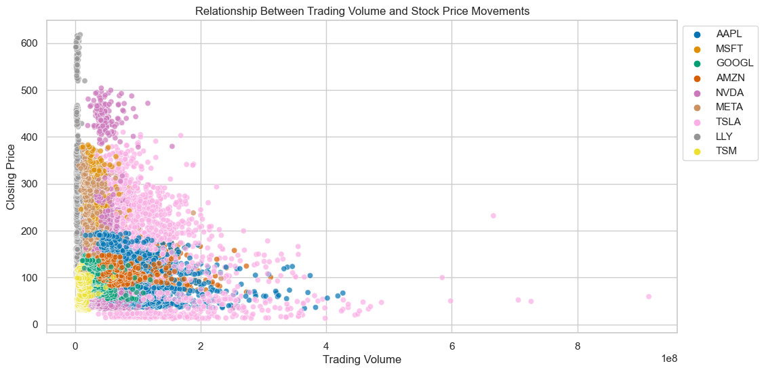

* There is no notable trend between stock splits and corresponding price changes. The datapoints are just everywhere.

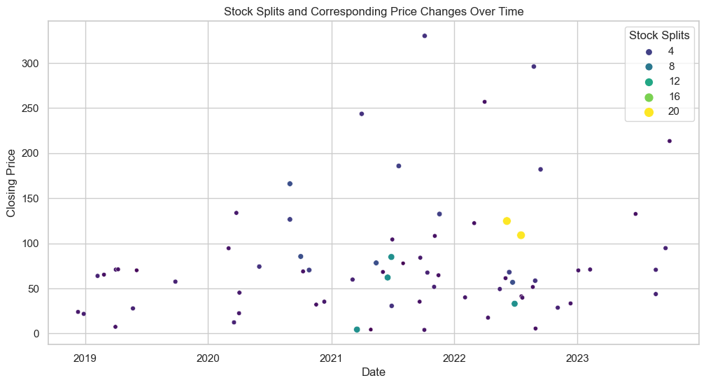

* TESLA, NVIDIA and META are the top companies with the highest volatility.

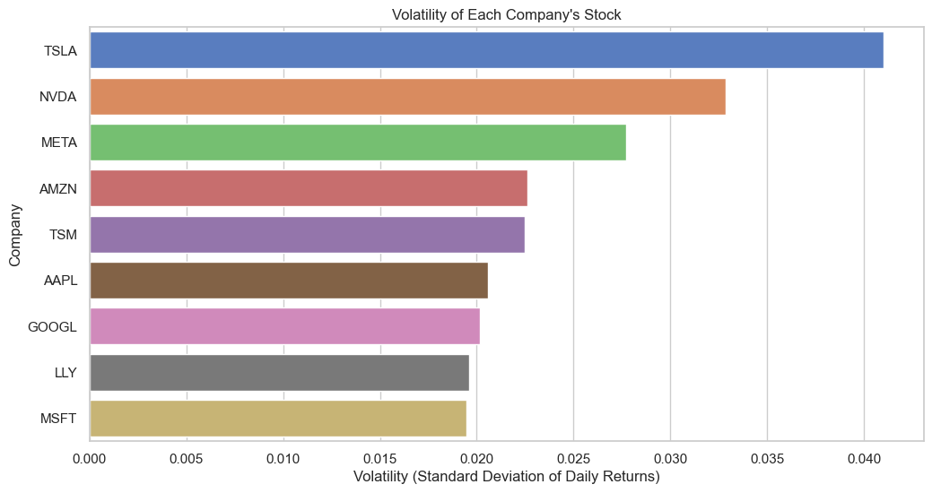

Volatility in stocks refers to the degree of variation of a stock’s price over time. A high volatility stock is one that experiences large fluctuations in price over a short period of time. This means that the stock’s price can change dramatically over a short time period in either direction.

A high volatility stock is inherently riskier, but that risk cuts both ways. It also has the potential for greater returns